17.118: a) With 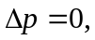
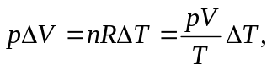
or
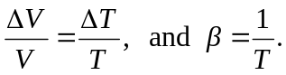
b) 